UNEARTHING THE ENVIRONMENTAL IMPACT OF HUMAN ACTIVITY :

A GLOBAL CO2 EMISSIONS ANALYSIS

CO2 Emissions :

* Co2 dioxide emissions or co2 emissions are emissions stemming from the burning of fossil fuels and the manufacture of cement. They include carbon dioxide produced during consumption of solid, liquid and gas fuels as well as gas flowing. Carbon dioxide emissions are the primary driver of global climate change.

CO2 Emissions : Human sources

* Since the industrial revolution, human sources of carbon dioxide emissions have been growing. Human activities such as the burning of oil, coal and gas as well as deforestration are the primary cause of the increased carbon dioxide.
* 87% of all human-produced carbon dioxide emissions come from the burning of fossil fuels like coal, natural gas and oil.The remainder results from the clearing of forests and other land use change(9%) as well as some industrial processes such as cement manufacturing(4%)

Some Ways to reduce CO2 Emissions :

* Avoid mass market, throw away fashion.
* Reduce your meat and diary consumption.
* Refuse single-use plastic.
* Reduce and rethink your transportation.
* Switch to green energy.
* Use renewable energy
* Purchase carbon effects.
* Purchase solar panels.
* Buy green bags.
* Adjust your thermostat.
* Install solar lights.

Impact of CO2 Emissions :

* Without carbon dioxide earth’s natural greenhouse effect would be too weak to keep the average global surface temperature above freezing. By adding more co2 to the atmosphere, people are super changing the natural greenhouse effect, causing global temperature to rise.

Impact of CO2 Emissions in Business activities :

* Business activities will be affected by more frequent extreme weather events (such as heat waves, droughts, heavy precipitation and increased intensity of cyclones) and by more gradual climatic processes (such as sea level rise, rising temperature, changingrainfall patterns). These changes will increase uncertainity, create risks for people and economics (job, losses impact on occupational safety and health. forced migrations) and involve costs.

In the absence of new policies, the macro economic costs from market impact amount to 10-33% annually by 2060 and to 2-10% by the end of the century (OCED Sources).

EMPATHY MAP :

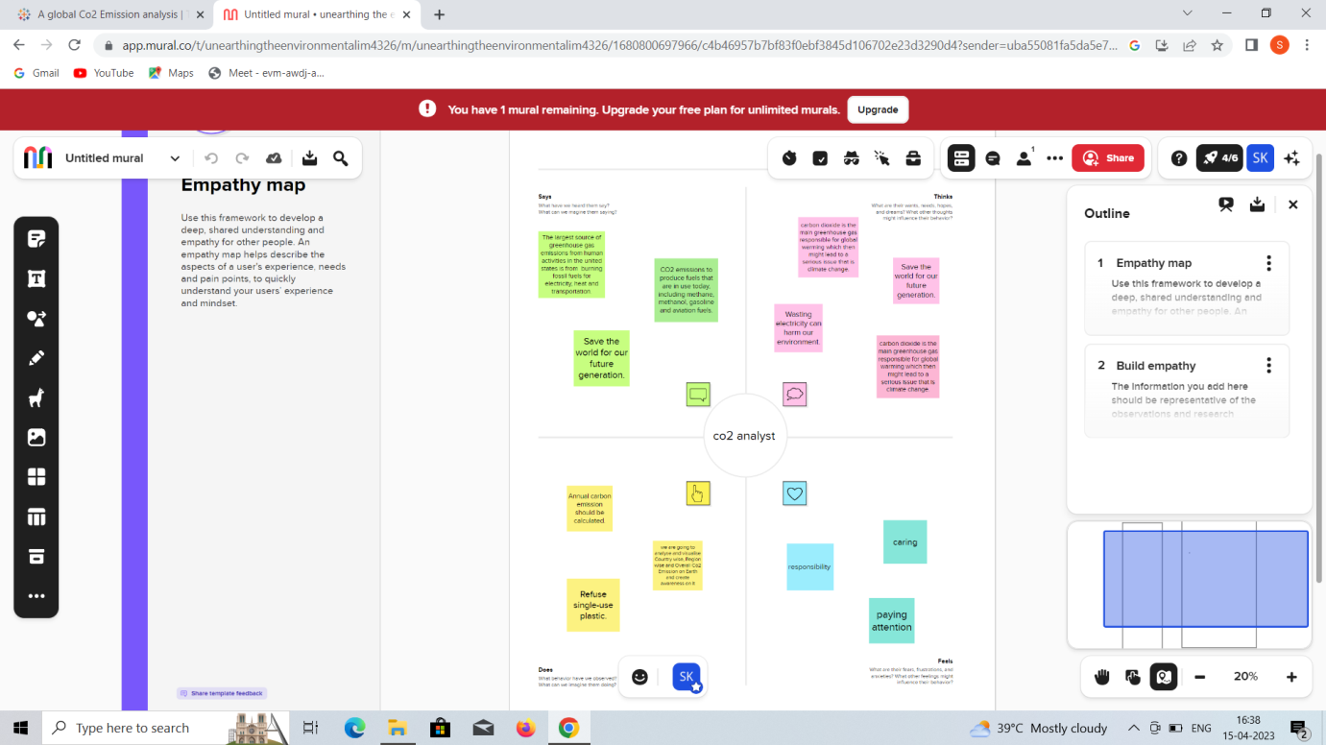

IDEATION AND BRAINSTORMING MAP :

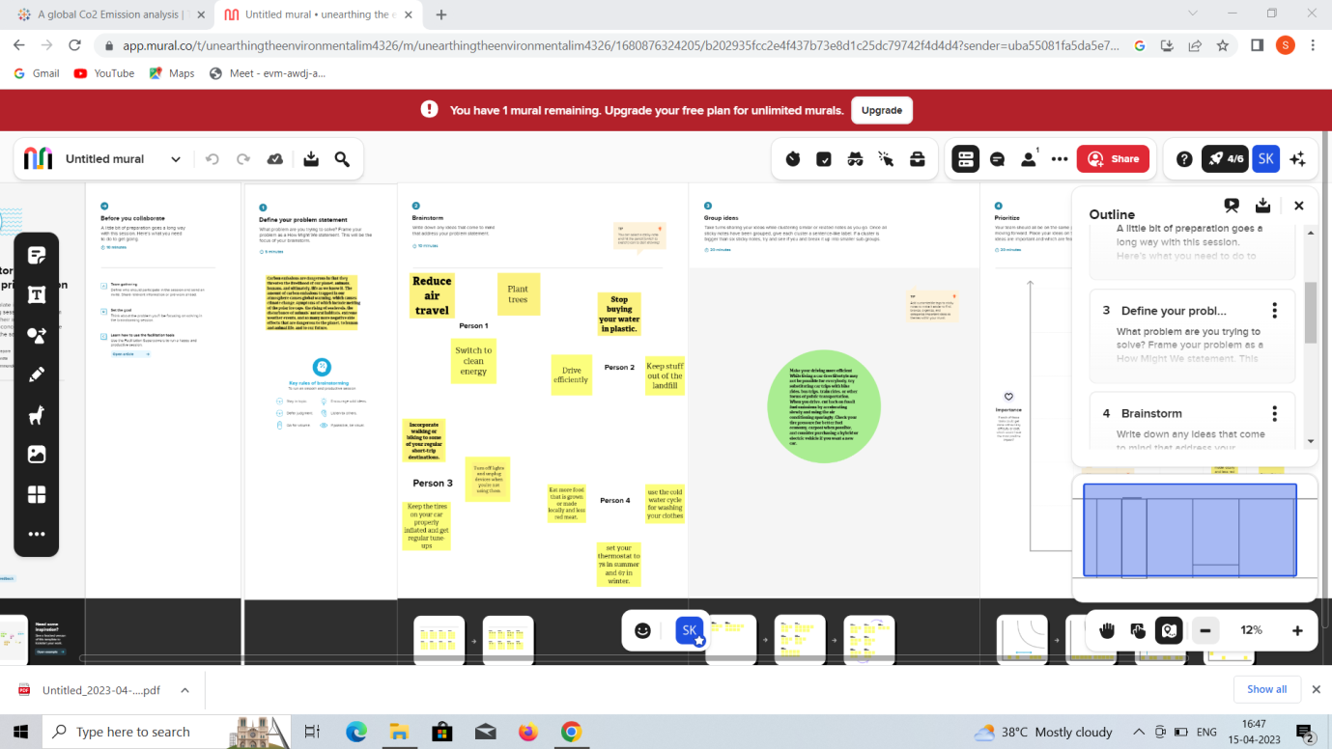

* This above map represents the details about what is the problem and what are the ideas of each team member and what are the group ideas and which should be prioritize first .

Its shows our clear idea about our project.

RESULTS:

* Here we share the final findings of the project like dashboard , story and web pages we create.

DASHBOARD:

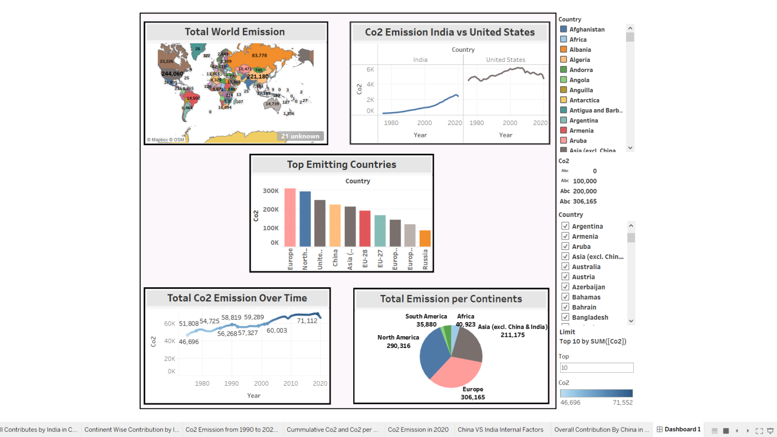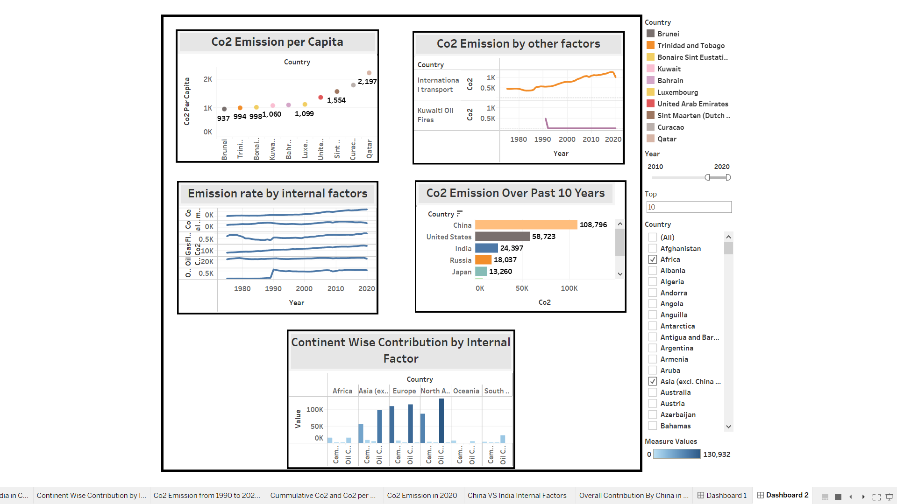

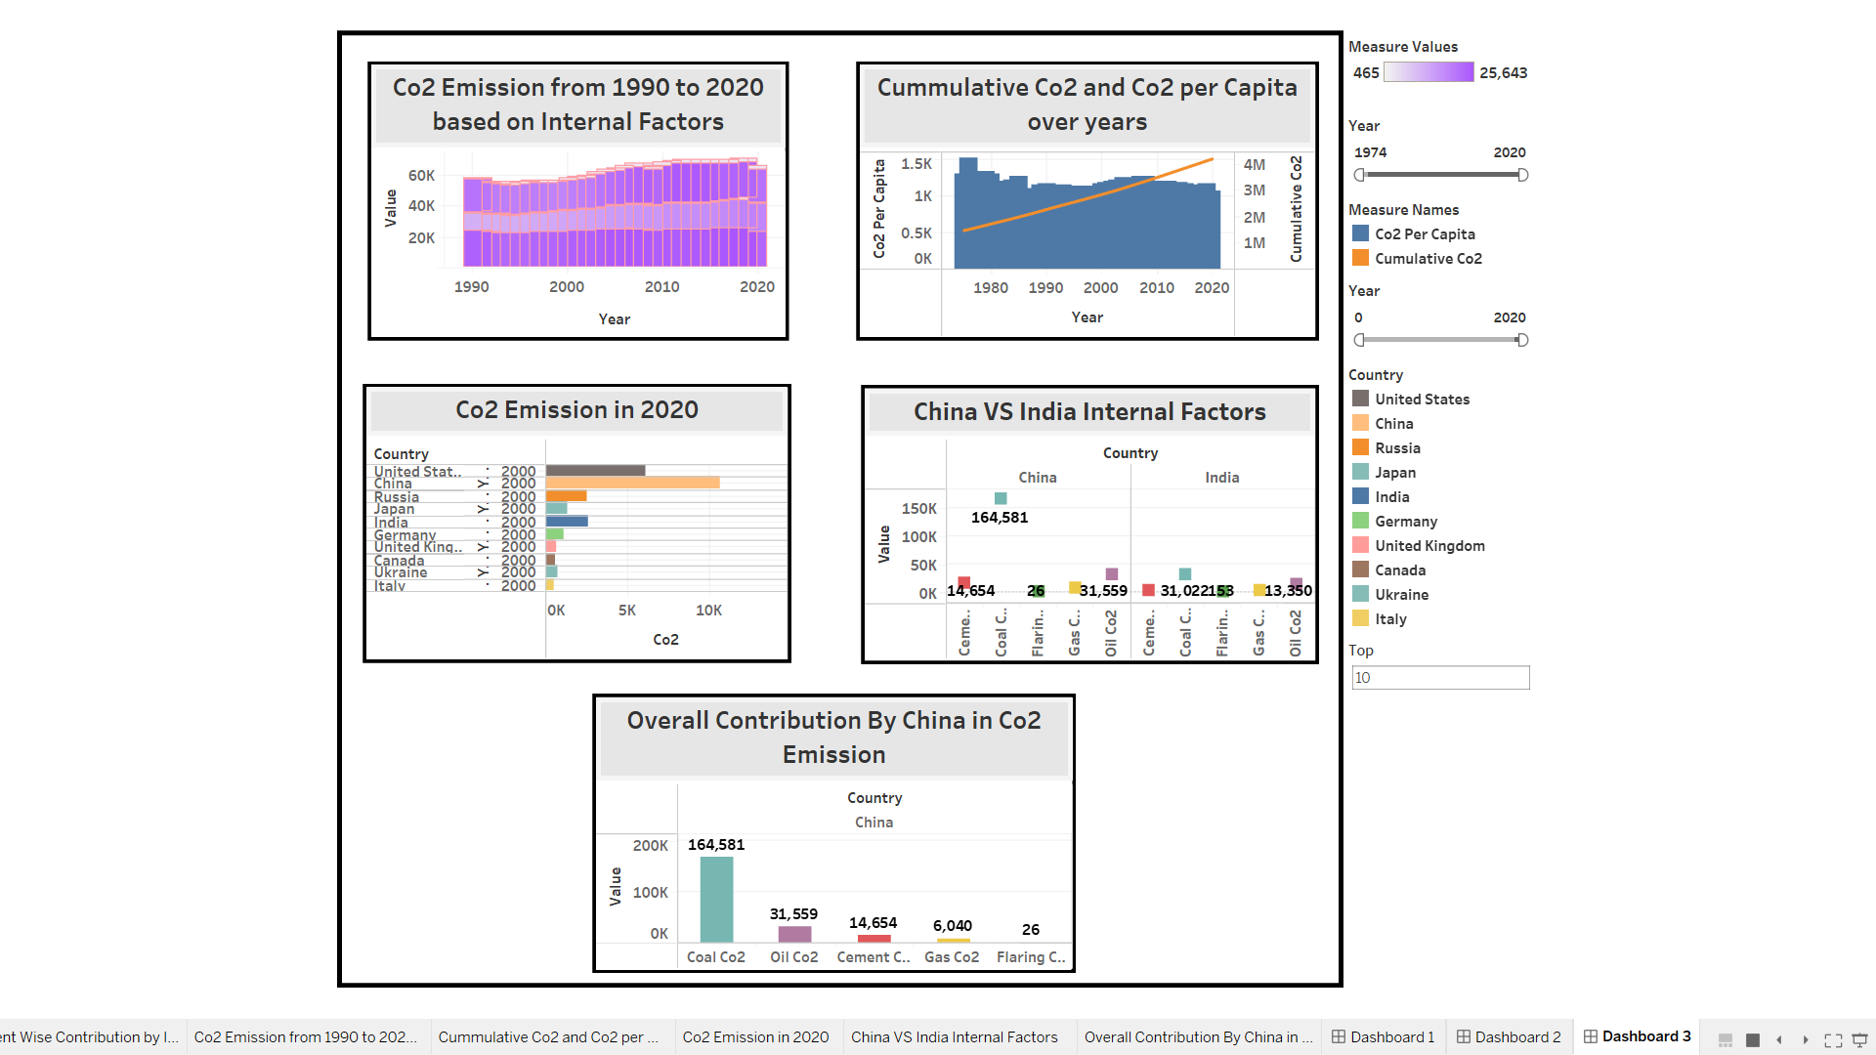

STORY:

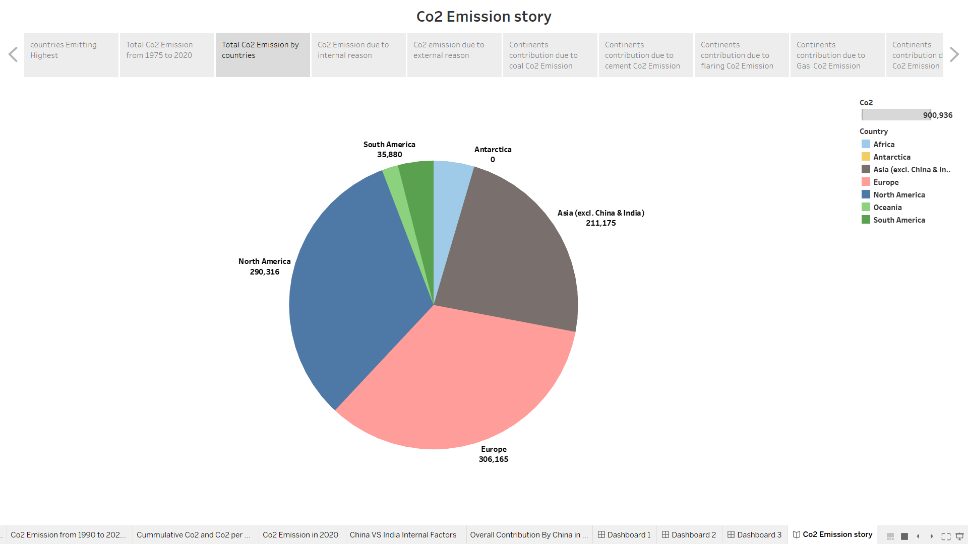

WEB INTEGRATION

OUTPUT:

* In this field we show you the web integration we made through HTML file and this is the final output of our project .

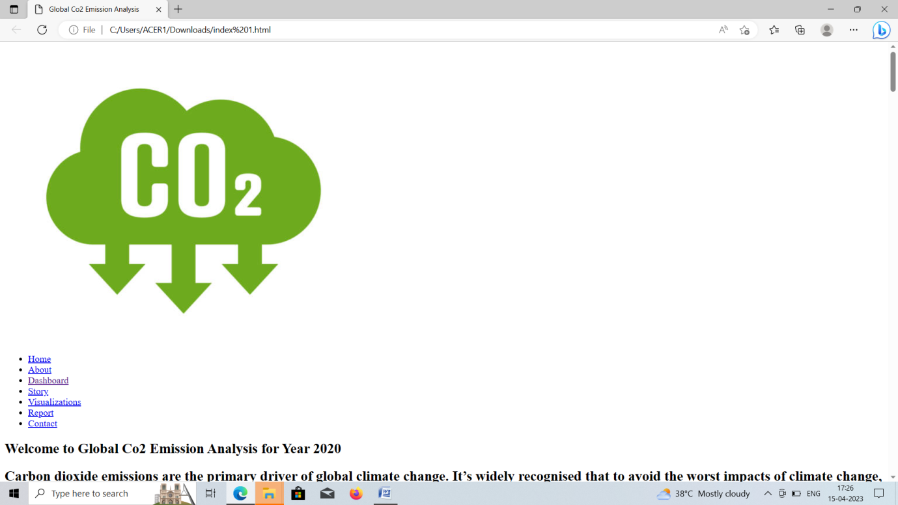

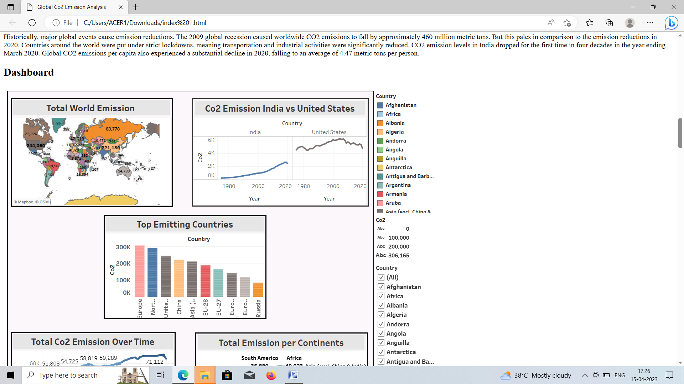

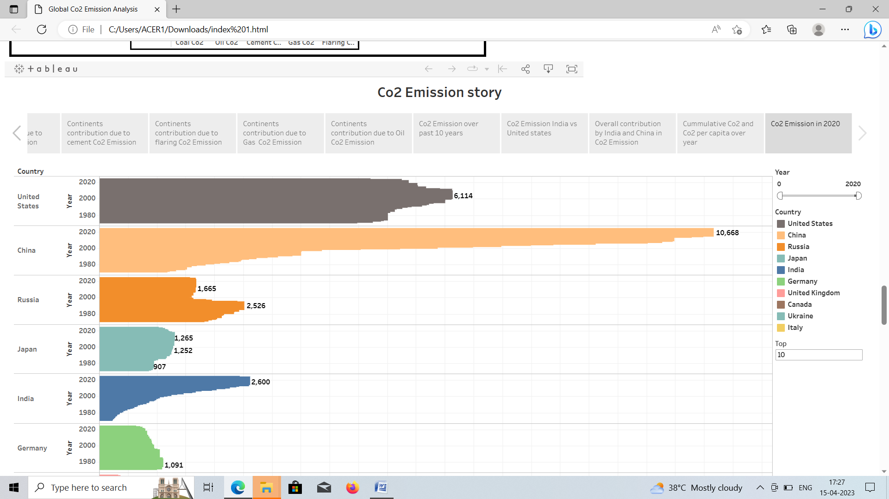

# ADVANTAGE :

* Carbon capture and storage is the one of the most efficient methods of extracting carbon emissions permanently from the environment .
* The numerous advantages of CCS include economic ,social ,and environmental and massive impact on a global and local scale .

# DISADVANTAGE :

* Co2 can be toxic and very harmful to humans, it increase the temperature of the earth atmosphere , it cause the global warming effect that has bad effects on the earth .

# CONCLUSION:

* We done our project by using tableau .In our project we build the visualizations and we drag all the visualizations to our stories also . After that we publish the visualization , dashboard ,story in Tabuleau public . Then for the next level we done the web integration by using Bootstrap made .
* In our project we understood how to analyze the data and how to create the new charts ,filter ,ect.